THE USE OF COMPUTER-BASED TECHNIQUES IN MODERN SPEECH THERAPY

IOLANDA TOBOLCEA & ADINA KARNER-HUŢULEAC

Abstract
Research which took into consideration the evaluation of efficiency when introducing modern Information Technology in speech therapy (for English language) has pointed out the big potential and the important benefits, as well as the existence of some risks and disadvantages in the case of their exaggerated usage. Therapeutic software which are more frequently met and used represent sets of thematic exercises and teaching games which are interactive and transform the classical teaching material (posters, palatograms, etc.) into an exceptionally wide range of clinical electronic materials. At the same time, we also observe the existence of intelligent software (computer-based speech therapy), which can perform complex evaluations and diagnosis of patients with speech disorders, 3D graphics of the phono-articulator (voice box) and it is important in preparations, evaluation of pronunciation and executing an audiovisual feedback in real time.
Keywords: speech therapist, therapeutic software, computer-based speech therapy

Computer-assisted speech therapy became more and more frequent in school practice starting with the period 1990-2000, with the development of computer based technology applications in a didactic context, for children and adults with or without learning difficulties [Anderson-Inman et al., 1996; Blankenship et al., 2005; Boon et al., 2006; Renard, 2000].
The following specialised software programs (for the English language) were developed in order to answer to the needs of specialists in the field of language pathology, which provides a wide range of attractive and stimulating formats, as well as didactic games for the vocabulary and the expressive and perceptive language development. The audio feedback completes the visual output, and the audio effects strengthen the impact of the animated visual rewards.
There are five main directions in using software programs within speech therapy.
1. for the articulation of sounds and words, several graphic formats that operationalise visually the pronunciation characteristics of the patient and also the articulation duration errors are used. The vocal capture and the graphical display represent a feedback of maximum impact (Figure 1):

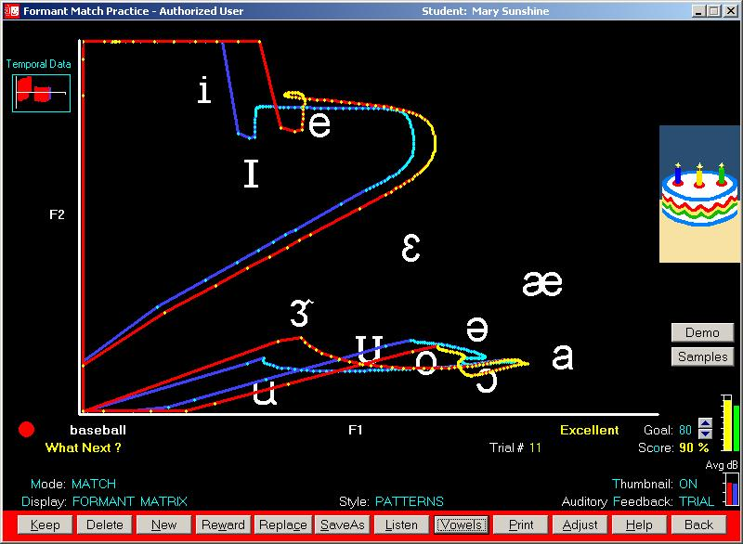
Figure 1: Format for the articulation of sounds and words

This graphical form is used in order to emphasize the differences and the similarities between the correct model and the child’s pronunciation and the practice until the two models correspond to an extent of at least 80%.
In order to eliminate the articulation duration errors, different formats are used (Figure 2); these formats include from a chronological point of view the pronunciation frequencies, providing thus a practical evaluation method for the pronunciation segments in the context of speech.

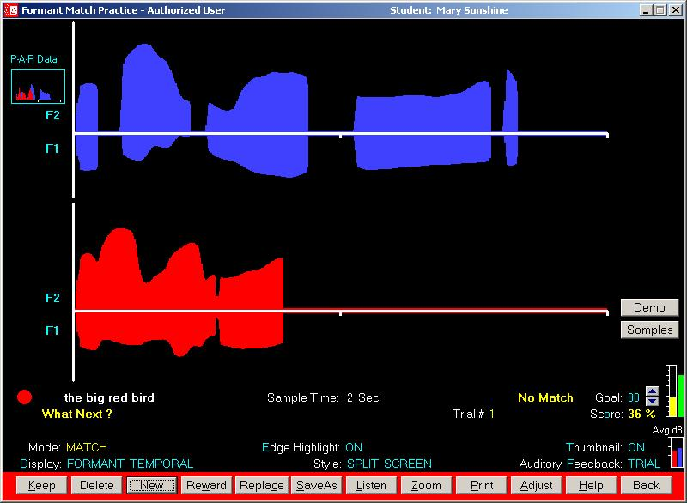
Figure 2 : Graphical format for highlighting the articulation duration

2. in order to gain awareness and to practice the voice volume, amplitude, intensity. In order to teach the patient what is the volume of his/her voice in a certain verbal production or in order to perform several volume modulations, one can use the Kaleidoscope (Figure 3), which functions on the basis of a colour pattern displayed on the monitor, directly related to the high or low sounds expressed by the child (measured in Hz).

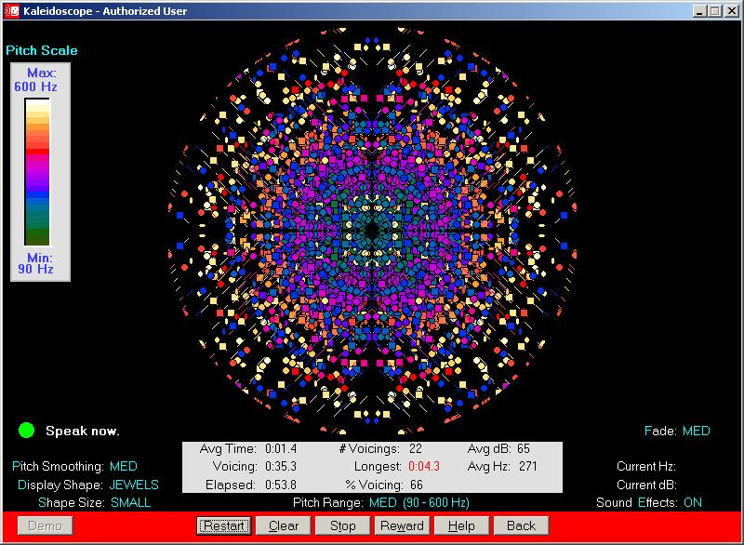
Figure 3: The Kaleidoscope – animated graphical format for highlighting the voice volume

In addition, the use of the computer in speech therapy is extremely important since it contributes to correcting some aspects of pronunciation, such as amplitude (Hz) (Figure 4):

Figure 4: Graphical form of the pronunciation amplitude (Hz)

Another aspect related to pronunciation correction is the intensity, measured in decibels (Figure 5):
Figure 5: Graphical form of pronunciation intensity (dB)

Similarly, one can also observe graphically: the inflexion of words or sentences, changes in speech rhythm and fluency, continuous phonation, co-articulation of phonemes, natural and distorted vocalization etc.

3. Games and graphical images that stimulate the effort of the patient in improving his/her pronunciation. In order to stimulate the correct verbal productions of the child, pleasant images can be used, displayed progressively, according to the level of accomplishment of the objectives established by the teacher-speech therapist, and according to patient’s disorders: the vocalisation duration, the continuous phonation or the pronunciation of certain sounds (Figure 6). Each pronunciation that corresponds to the correct model will be followed by the completion of an image segment. The hidden images are split in a variable number of parts, established by each speech therapist.

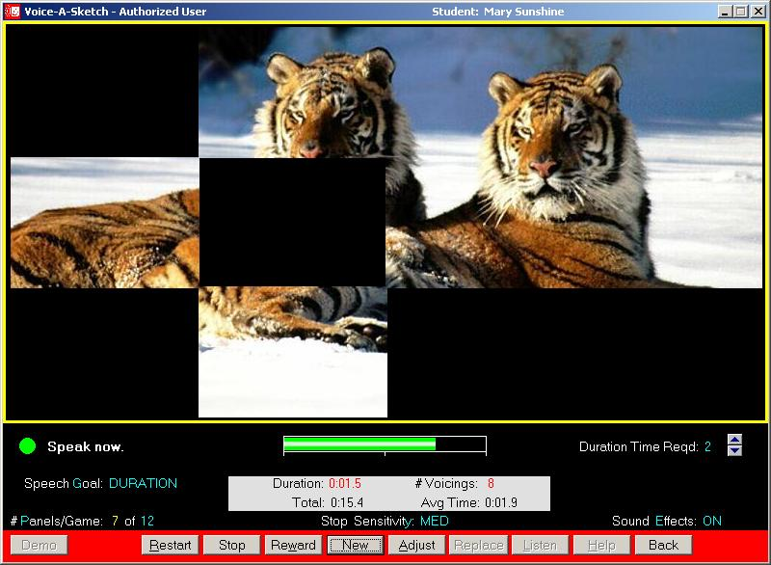
Figure 6: Hidden image for stimulating the pronunciation quality

4. The therapeutic software programs the most frequently met and used represent ensembles of thematic exercises and interactive didactic games that transform the classical didactic material (posters, palatograms, etc) into an extremely wide range of electronic clinical materials. For example, in vocabulary development, one can use didactic games (Figure 7) in which the patient is required to indicate the graphical representations associated to a name starting by a certain sound.


Figure 7: Interractive didactic-therapeutical game for vocabulary development

5. Ongoing evaluation can be presented quantitatively and/or graphically (Figure 8), obtaining a general image in the child’s evolution throughout the speech therapy intervention, the rhythm of the positive pronunciation modifications; also, suggestions can be displayed for the modification of the types of exercises, the short or long term therapeutic objectives, the specific techniques, etc.

Figure 8: Graphical representation of the patient’s evolution following the therapeutic intervention

In 1991, Cotton carried out a study in order to evaluate the effect of introducing computer-based technology in the speech therapy of disabled children. It was observed that the strongest effect was recorded in the children with learning disorders, in those with auditory disorders, language disorders or emotional disorders, which determined an orientation of the American governmental clinical research funds towards this field. It is noticeable that in Romania, just like in the USA, most speech therapists still use traditional speech therapy methods, that can be defined as a set of specific techniques, involving listening, imitation and the physical modelling of the phono-articulatory apparatus and many exercises that have to be practiced systematically [Secord 1989].
This therapeutic approach has undoubtedly the efficiency and the value demonstrated by the numerous children that improved or healed their language disorders, but any practitioner speech therapist can admit that this sustainable repetition technique for the correct pronunciation of sounds, syllables, words and sentences entails a decrease in the interest and motivation for practicing, since it involves a certain tiring monotony and regress.
This is precisely why a combination of the traditional techniques with the new informatics technology in speech therapy could lead to the stimulation of the child’s motivation for systematic practicing, accelerating thus the therapeutic progress. Nevertheless, the computer is not a therapeutic means per se, being an educational tool that can be used in a great variety of forms in order to support numerous technological interventions necessary in language therapy [MacArthur and Malouf, 1991]. Other authors suggested that the new computer-based technology used for therapeutic purposes can help traditional speech therapy by creating an updated atmosphere in the therapy cabinet, that keeps up with the ludic and working realities of children in the 21th century; it can also improve the therapeutic relations, with a view to eliminate the frustration activated by the monotonous exercises suggested by the speech therapist, potentially leading indirectly to the increase in the children self-esteem [Miller şi Marriner, 1986].
This is why numerous types of therapeutic software were created for the English language (Ortho-Logo-Paedia, Laureate Learning Systems, STAR System, AphasiaMate, CHAT, Chatback, Protrain, VideoVoice etc.), and also for the Romanian language (Ecofon, Logoped 1.0., SEBRAN 1.37, DISLEX-TEST, LOGOMON, TELPROT), which proved their efficiency in forming the correct pronunciation skills, in developing speech in general, in improving the affective life and in stimulating imagination.
It is important to point out the realization of the first intelligent software for the Romanian language (computer-based speech therapy), which can carry out complex evaluations and diagnose the patients, the 3D graphic of the phono-articulatory apparatus, extremely important in the impostation stage, pronunciation evaluation and executing an audio-visual feedback real time. The creation of this software was carried out within en excellence project CEEX (TERAPERS), in which collaborated the “Alexandru Ioan Cuza” University of Iaşi, the “Ştefan cel Mare” University of Suceava, and the “Gh. Asachi” University of Iaşi [Karner-Huţuleac et al., 2008; Pentiuc et al., 2008; Puzdriac et al., 2008; Tobolcea, 2007; Tobolcea et al., 2007, 2008, 2009; Zaharia et al., 2008].
The objective was the realization of a system formed of the calculation system of the speech therapist and a mobile device, with a “friendly” and easy to use interface, by means of which the dyslalic child works both in the speech therapist cabinet and at home, in solving the exercises recommended by the speech therapist.
At the end of the project was implemented the Logomon computer-based therapy system (Fig.9), which includes classical modules such as the 3D articulation module, the management system for homework (installed on the child’s PC or PDA), the management system of the therapeutic tasks realized in the therapy cabinet, and also an expert system used in decision making related to the optimal therapeutic activities that should be followed for each dyslalic child (number of sessions, content of the therapeutic exercises, etc.). It is important to point out the fact that the decisive factor in the therapeutic process is the speech therapist. For each patient, the expert system can generate optimal sets of exercises, based on specific data (results in the tests used within the complex evaluation, affective and social cognitive parameters, etc.).

Figure 9: Computer assisted therapy system for dyslalia – Logomon

For the children with severe language disorders or with other associated disorders, for whom the compensation of speech disorders can only be made partially, one can used standardized software applications (for the English language) [Lahm and Nickels, 1999]. For example, the word processing systems allow the pupils with severe disabilities to monitor and correct the materials they wish to write by using the keyboards. For these pupils, numerous software programs were created in order to check the spelling, the punctuation, the grammar, facilitating thus the development of the graphical abilities [Schetz and Dettmar, 2000]. Nevertheless, sometimes even this help is insufficient, since the pupil with severe disabilities has major problems in choosing the correct option from the options list displayed on the monitor for the words misspelled.
Another deficient ability in these children is the organization of their daily activities. Therefore, numerous programs for assisting the persons with learning disabilities also include computer-based applications for data management (PDAs), [Raskind, 1993], helping them in solving time management problems. It is obvious that for integrating these technologies at the level of the individualized educational programs, specialty training oriented towards the use of the computer and running these software applications is highly necessary.
As far as the assisting technology is concerned, a great variety of devices are used according to the specific disorder. For example, for children with vision deficiencies are used programs for the modification of the characteristics of the letters, or devices for synthesizing the artificial voice that transforms the graphical code into audio code, modified keyboards, etc.
All the researches that had in view the evaluation of the efficiency of the modern informatics means used in speech therapy (for the English and the Romanian language) unanimously emphasized the great potential and the important advantages they bring in the treatment of the children with speech disorders, with or without other associated disorders.

BIBLIOGRAPHY

Andeson-Inman, L., Knox-Quinn, C., Horney, M.A., 1996, “Computer based study strategies for students with learning disabilitiei: individual differences associated with adoption level”, in Journal of Learning Disabilities, 29, pp. 461-485.
Blankenship, T., Ayres, K, Langone, J., 2005, “Effects of computer based cognitive mapping on reading comprehension for student with emotional behaviour disorders”, in Journal of Special Education Technology, 20, pp. 15-23.
Boon, R.T., Fore, C., Burke, M.D., Hagan-Burk, S., 2006, Students’ attitudes and perceptions toward technology: What do the users have to say, Council for Exceptional Children, Salt Lake City, UT.
Cotton, K., 1991, Computer-assisted instruction, Northwest Regional Educational Library: School Improvement Research Series, 19.
Karner-Huţuleac, A.-N., Tobolcea, I., Puzdriac, C., Zaharia, D., 2008, “Analiza sistemelor CBST (computer-based speech therapy) utilizate în cercetarea şi practica logopedică a tulburărilor de vorbire (pentru limba engleză)”, in Tobolcea, I. and Turliuc, M.-N. (Eds.), Actualităţi şi perspective în practica logopedică, Sfera, Iaşi.
Lahm, E.-A., Nickels, B.-L., 1999, “What do you know? Assistive technology competencies for special educators”,in Teaching Exceptional Children, 32(1), 56-64.
MacArthur, C.-A., Malouf, D.-B., 1991, “Teachers’ beliefs, plans, and decisions about computer-based instruction”, in Journal of Special Education, 25(1), pp 44-72.
Miller, J.-F., Marriner, N., 1996, “Language intervention software: Myth or reality”, in Child Language Teaching Therapy, 2(1), pp. 85-95.
Pentiuc, S.-G, Schipor, O.-A, Danubianu, M., Schipor, D., 2008, Therapy of Dyslalia Affecting Pre-Scholars, Third European Conference on the Use of Modern Communication Technologies – ECUMICT 2008, Gent, Belgium.
Puzdriac, C., Tobolcea, I., Karner-Huţuleac, A.-N., Zaharia, D., 2008, “Implementarea mijloacelor moderne in terapia logopedica a tulburarilor de limbaj”, in Tobolcea, I. and Turliuc, M.-N. (Eds.), Actualităţi şi perspective în practica logopedică, Sfera, Iaşi.
Raskind, M., 1993, “Assistive technology and adults with learning disabilities: A blueprint for exploration and advancement”, Learning Disability Quarterly, 16, pp 185-198.
Renard, L., 2000, “Cut and paste 101 : Plagiarism and the net”, Educational Leadership, 57(4), pp. 38-43.
Schetz, K.F., Dettmar, E., 2000, “Collaborating with technology for at-risk readers”, Teaching Exceptional Children, 32(4), pp. 22-27.
Secord, W.A., 1989, “The traditional approach to treatment”, în V. Knight, (Ed.), Assessment and Remediation of Articulatory and Phonological Disorders. Second Edition, pp. 129-153, NY: Macmillan Publishing Company, New York.
Tobolcea, I., 2007, “Sisteme informatice pentru asistarea logopedului în stabilirea terapiei personalizate a tulburărilor de limbaj”, Sisteme distribuite, Universităţii, Suceava.
Tobolcea, I., Karner-Hutuleac, A-.N., Puzdriac, C., Zaharia, D., 2007, “Terapers - sistem informatic pentru terapia logopedică personalizată a tulburărilor de pronunţie”, in vol. Congresului Internaţional de Psihologie Cercetarea psihologică modernă: direcţii şi perspective, Sibiu.
Tobolcea, I., Pentiuc, S.-G., Karner-Huţuleac, A.-N., Puzdriac, C., Zaharia, D., 2008, “Transpunerea programelor logopedice clasice în pseudocod algoritmizat”, in Tobolcea, I. and Turliuc, M.-N. (Eds.), Actualităţi şi perspective în practica logopedică, Sfera, Iaşi.
Tobolcea, I., Pentiuc, S.-G., Danubianu, M., 2009, “Folosirea tehnologiei informaţiei şi comunicării în procesul de învăţare a copiilor cu cerinţe educaţionale special”, in Sisteme distribuite, pp.105-109, Editura Universităţii, Suceava.
Zaharia, D., Tobolcea, I., Karner-Huţuleac, A-.N., Puzdriac, C., 2008, “Percepţia impactului mijloacelor multimedia din terapia logopedică în rândul părinţilor, educatorilor şi logopezilor”, in Tobolcea, I. and Turliuc, M.-N. (Eds.) Actualităţi şi perspective în practica logopedică, Sfera, Iaşi.

„Alexandru Ioan Cuza” University of Iaşi, Faculty of Psychology and Educational Sciences. E-mail: itobolcea@yahoo.com
„Alexandru Ioan Cuza” University of Iaşi, Faculty of Psychology and Educational Sciences. E-mail: adinakarner@yahoo.com

